MACH4METAL

metalworking machinery
Transito 21, 6909 DA Babberich, Netherlands
Tel. + 31 (0)316 – 247123
Fax. + 31 (0)316 - 247956
info@mach4metal.com
www.mach4metal.com
Bank No : 66.52.13.883
IBAN : NL33 INGB 0665 2138 83
BIC : INGBNL2A
VAT : NL 815393635B01

MAZAK SQT 250 MS driven tools sub spil

- Make : MAZAK - Yamazaki
- Type : SQT 250 MS
- Serial NO :
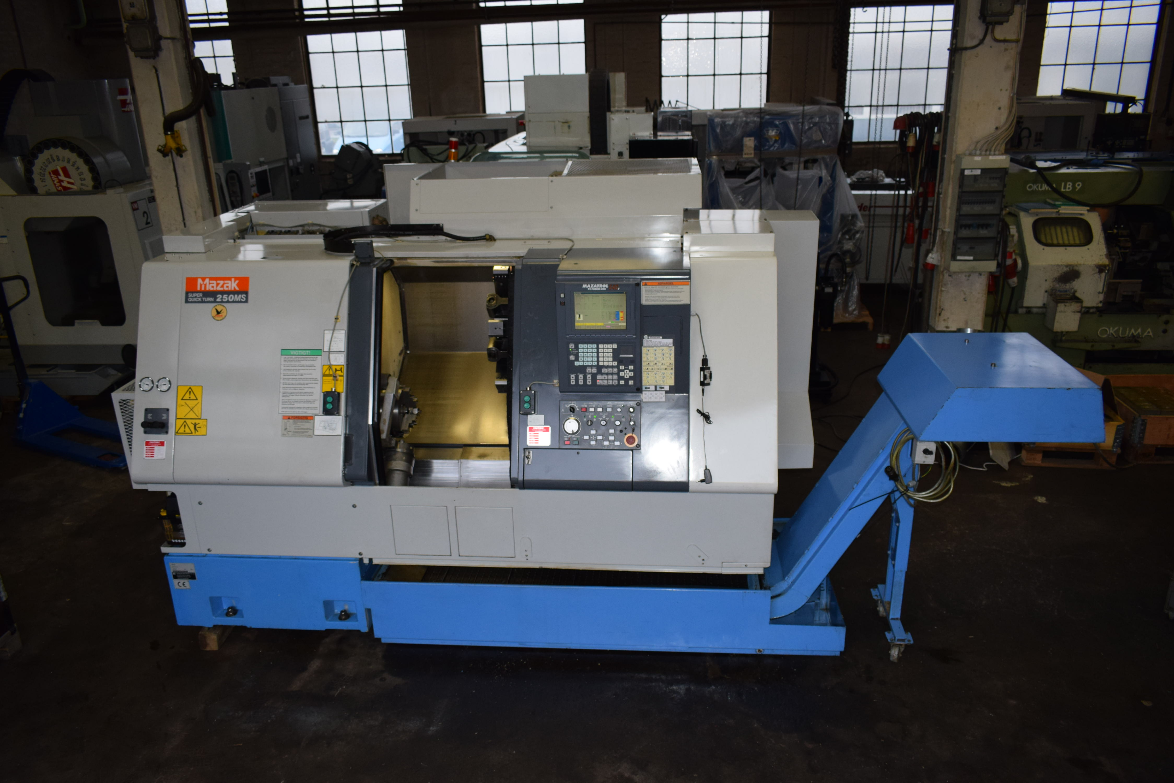
- Age : 2002

- Capacity
- Max. swing Ø : 525
- Machining swing Ø : 300
- DBC turning length : 540

- Spindle bore : 64
- X travel : 190
- Z travel : 575
- W travel : 585
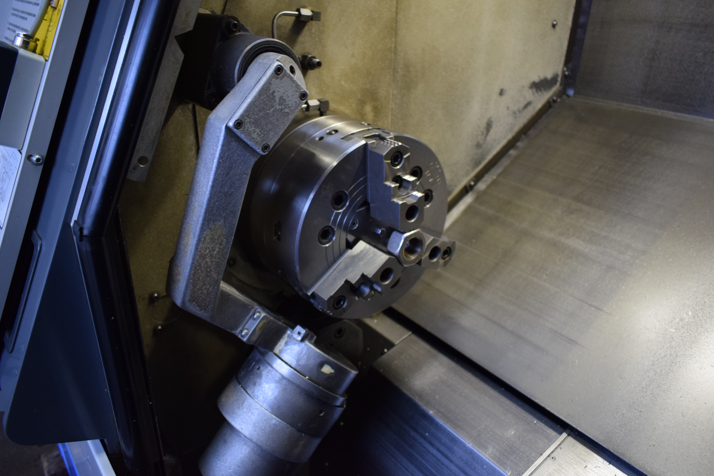
- Spindle speed : 4.000
- C Axis : 0.001 Gr
- Power : 18.5 kW

- ATC revolver : 12 positions
- Live tooling speed : 4.500 Rpm
- Sub spindle stroke : 5 Gr
- Sub spindle speed : 4.000 Rpm

- CNC MAZATROL Fusion 640T
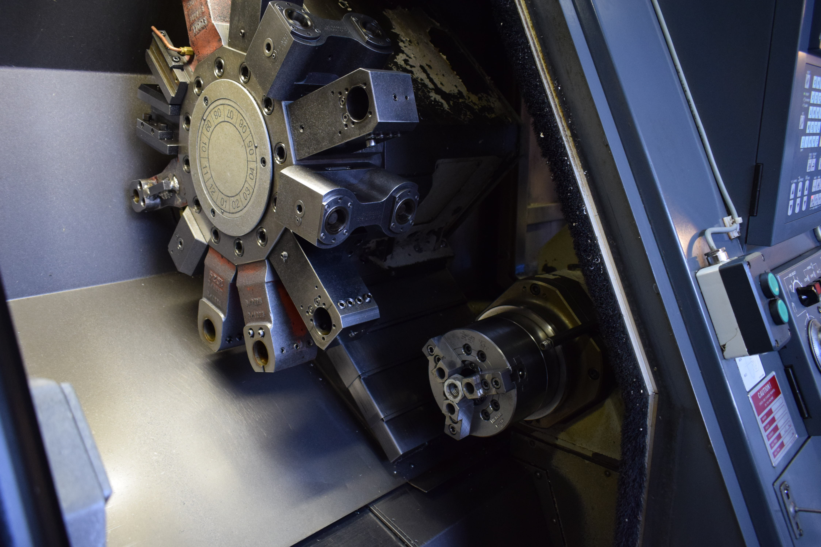
- Working hours 6100 H
- Chip conveyor
- Tool pre setter

- Dimensions

- Length : 3450
- Width : 2000
- Height : 1800
- Weight : 5450

Please Note: The above information has been obtained to the best of our ability and belief from, and from the manufacturers where possible. It is given in good faith, but its accuracy can not be guaranteed. Accordingly, it will not form a representation or constitute contractual terms. We advise you to check any vital details

